Lab: DSX Flows

October 30th, 2017

Author: Elena Lowery elowery@us.ibm.com
Table of contents
Contents
Overview 1
Required software, access, and files 1
Part 1: Create a DSX Project and Load Data 1
Part 2: Create a Flow 2

Overview
In this lab you will learn how to implement analytics in the Flows interface of the Data Science Experience.

Required software, access, and files

To complete this lab, you will need an account in DSX: https://apsportal.ibm.com/analytics

You will also need to download and unzip this GitHub repository: https://github.com/elenalowery/DSX-Local-Telco-Churn

Part 1: Create a DSX Project and Load Data

- Log in to DSX: https://apsportal.ibm.com/analytics

- Create a project. You can provide any name.

- Switch to the Assets tab and click on New Data Asset.

- Click Browse. Navigate to the data folder of the unzipped GitHub repository and import customer.csv and churn.csv

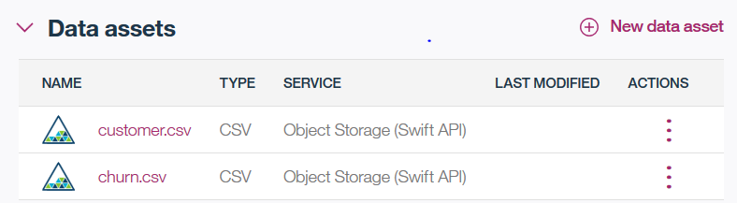

Part 2: Create a Flow

- On the Assets tab scroll down to Flows and click on New Flow

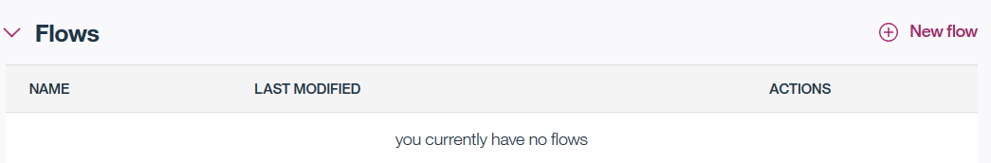

- Name the flow TelcoChurn and make sure IBM SPSS Modeler runtime is selected. Click Create Flow.

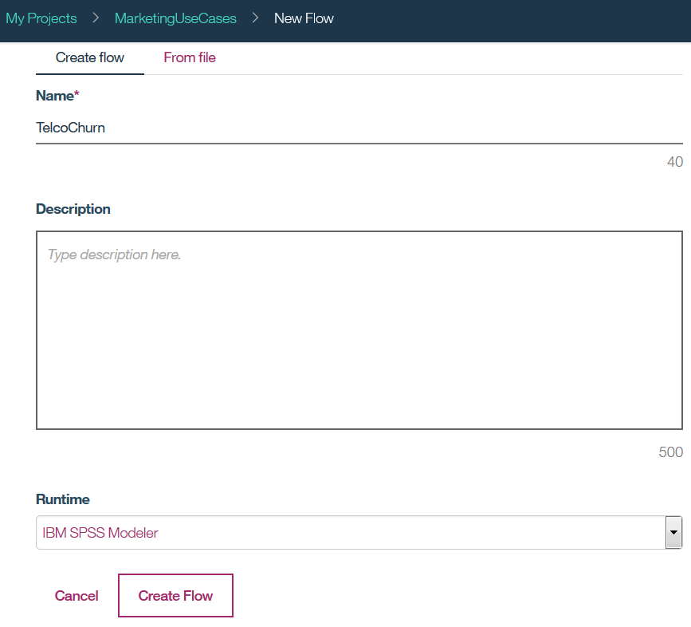

- Drag and drop customer and churn data source to the canvas.

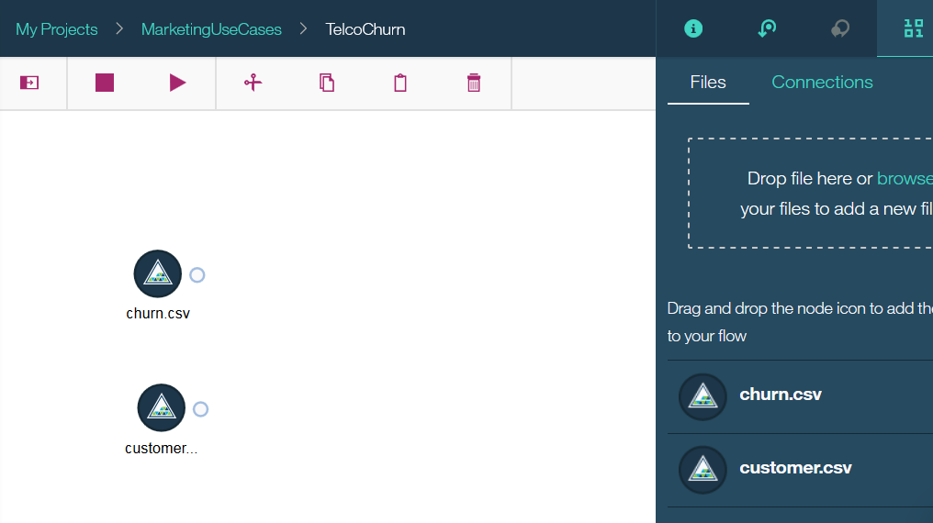

- Right mouse click on the data source in the canvas and select Preview to view the data.

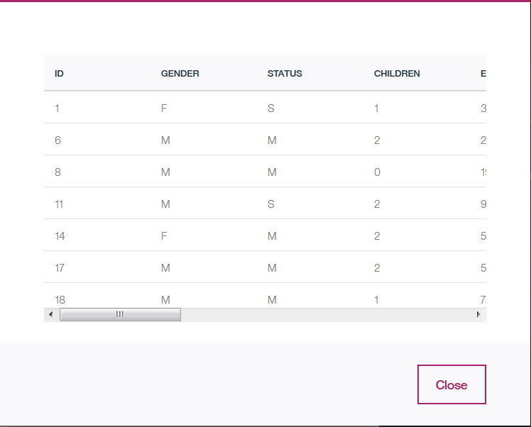

- Click on the Palette icon and expand Record Operations.

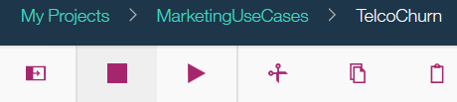

- Add the Merge node then connect the customer and the churn data sources to it.

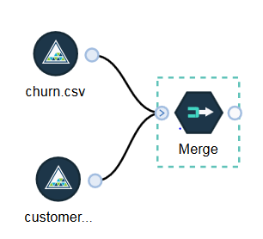

- Double click on the Merge node. Select Keys as the Merge method.

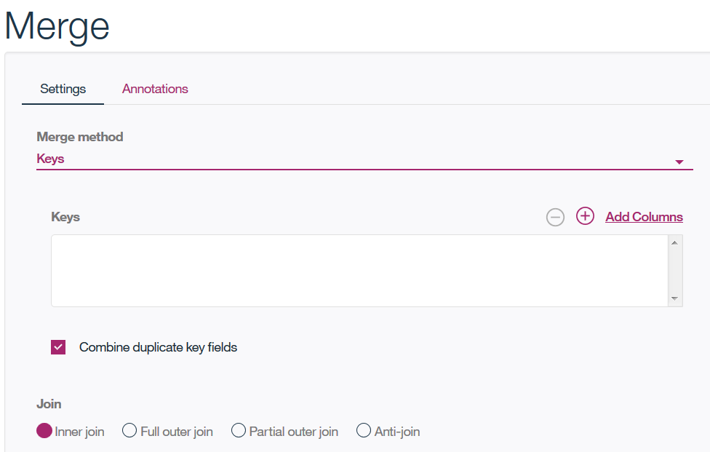

- Click Add Columns and select the ID filed. Click Select Fields for Merge to return to the previous screen.

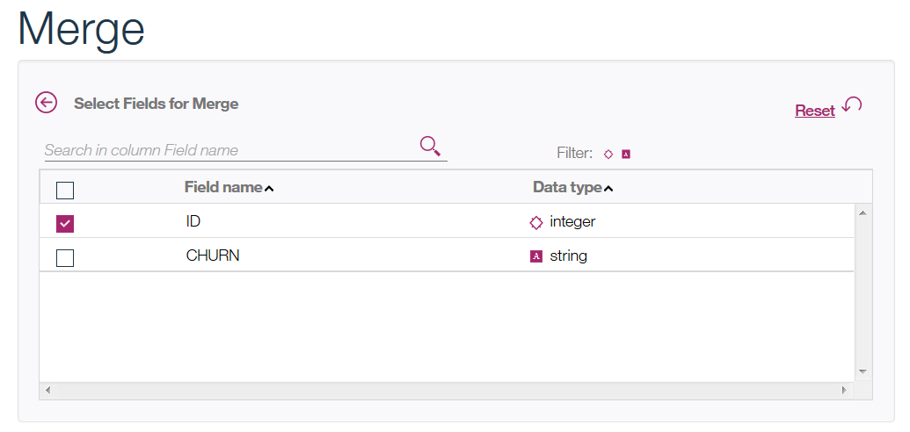

- Now the Merge screen looks like the following screenshot. Click OK.

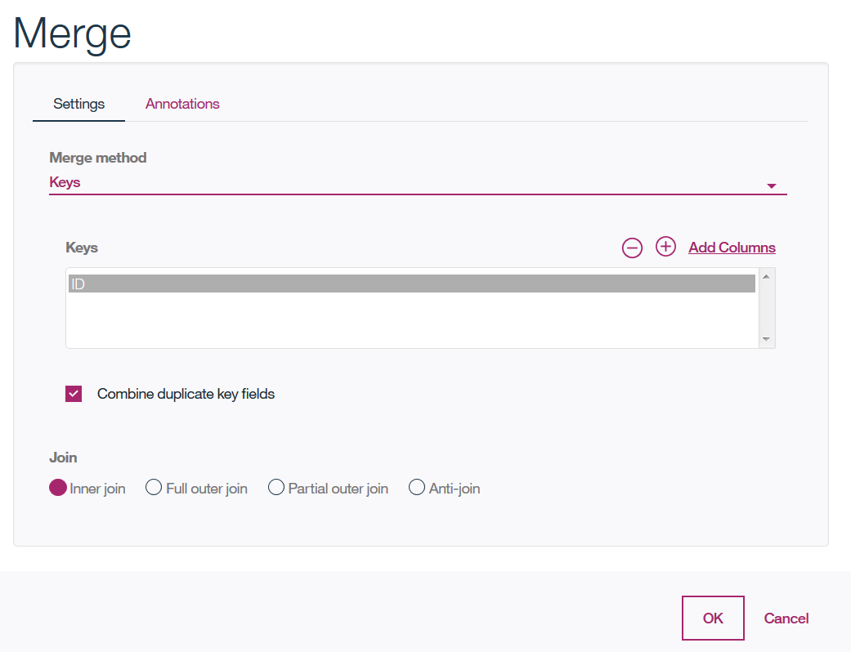

- Next, you can connect the merged data to different types of graphs to get a better understanding of data. For example, you can add a Distribution graph and display churn by gender.

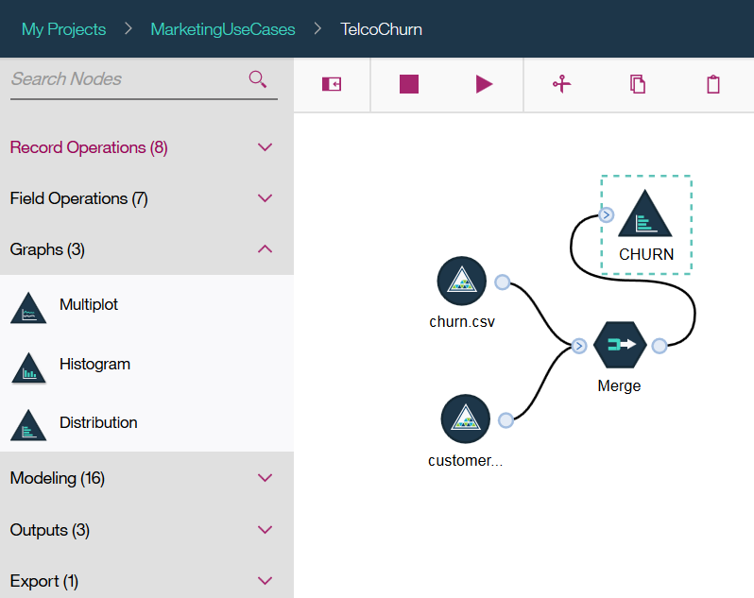

- Double click on the Distribution node to edit it. Then right click and select Run.
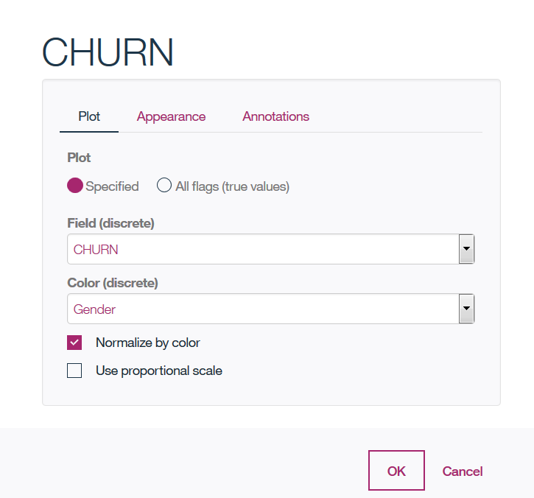

- Output is shown in the Ouputs panel. Double click to display it.

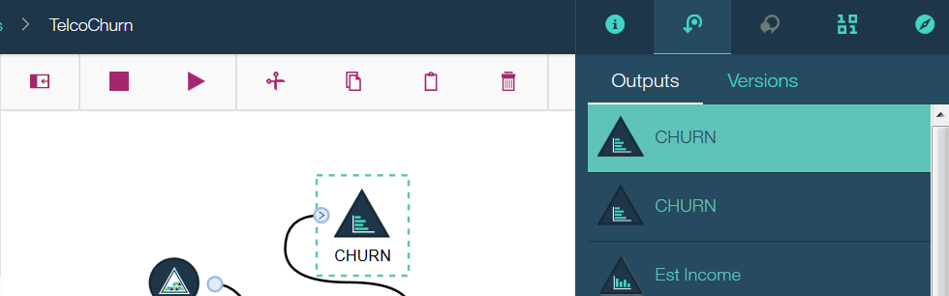

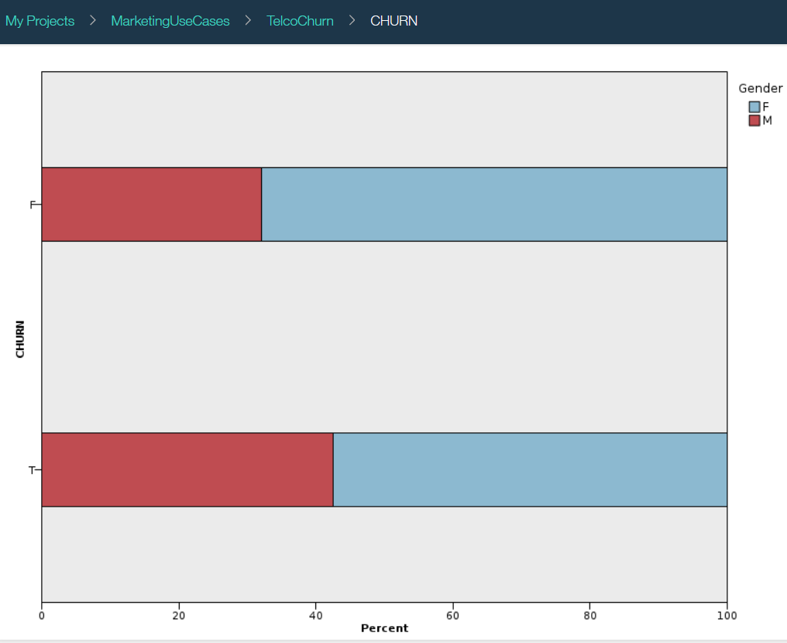

- Next, we are going to build a model for predicting churn. Add a Type node from the Field operations and connect it to the Merge node.

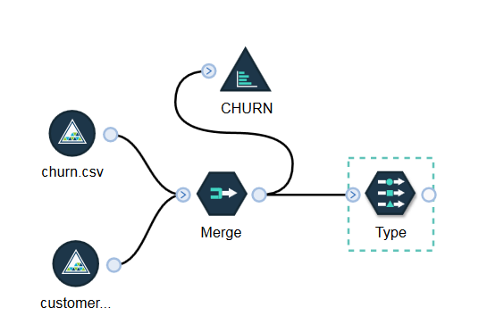

- Double click on the Type node and click Add Columns. On this screen we are selecting the fields that will be used for modeling.

- Select all fields with the exception of ID (because ID is not a predictor for customer churn). Return back to the main screen and change Role of CHURN field to Target and Measure to Flag because that’s the value we would like to predict.

Click OK.

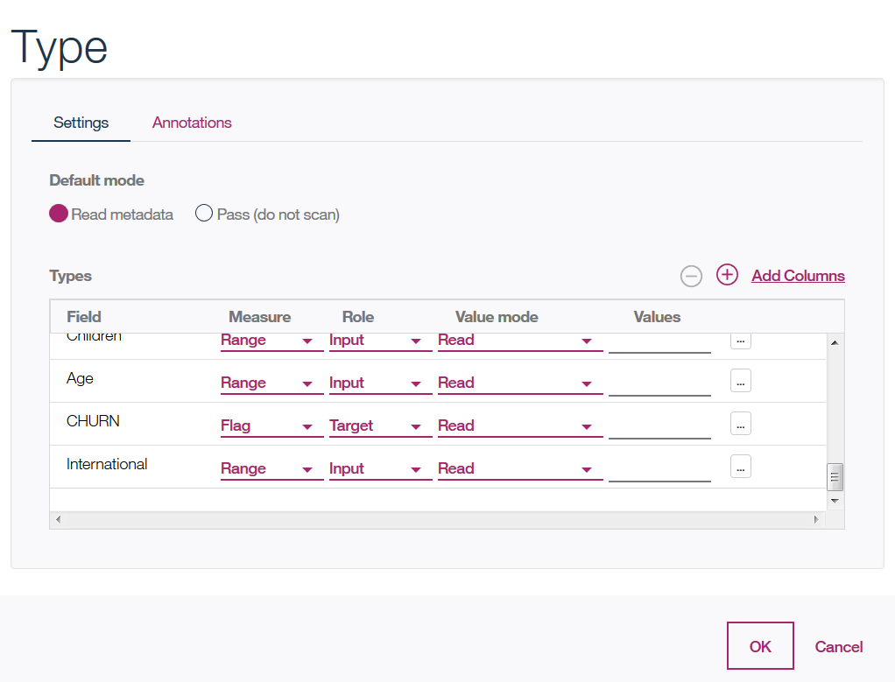

- Add the C5 node from the Modeling tab. The C5 is a popular decision tree algorithm.

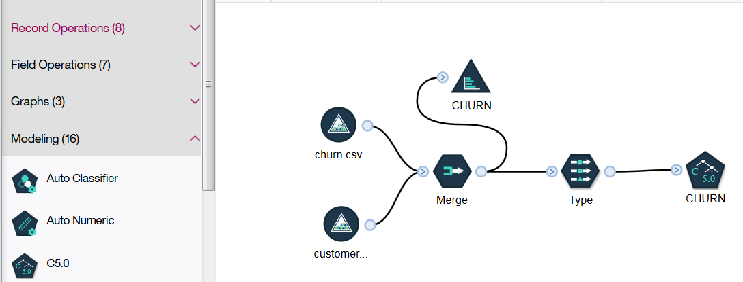

- Right click on the C5 node on the canvas (CHURN) and select Run.

- Model building will take a few minutes. When model building is done, you’ll see a model nugget on the canvas.

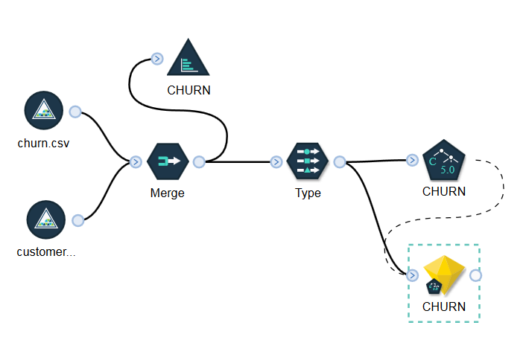

- Right click on the model nugget and select View Model. Explore the model. For example, Top Decision Rules tab shows the combination of predictors that result in specific customer churn value.

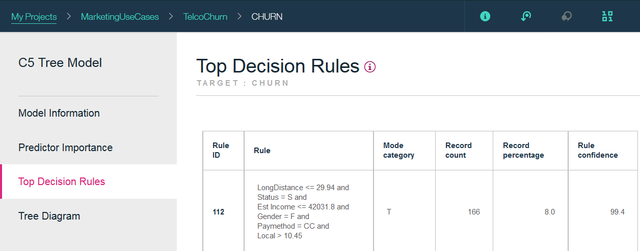

- Finally, add a Table (from Outputs tab) and an Object Store (from Export tab) nodes and connect them to the model nugget.

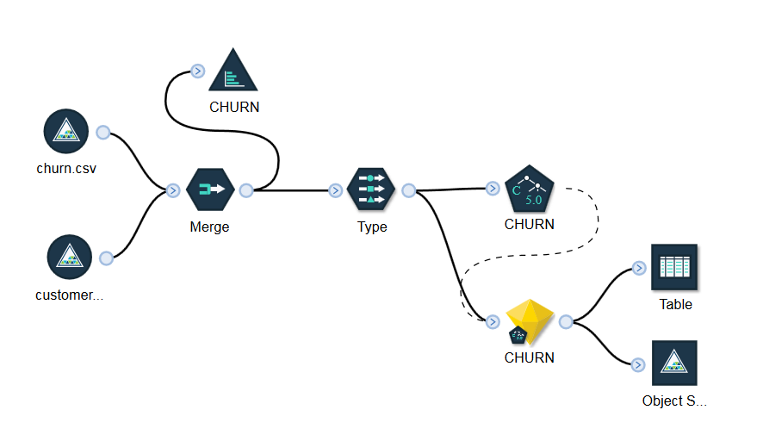

- Double click on the Object Store and provide file name, for example, ScoringOutput.csv.

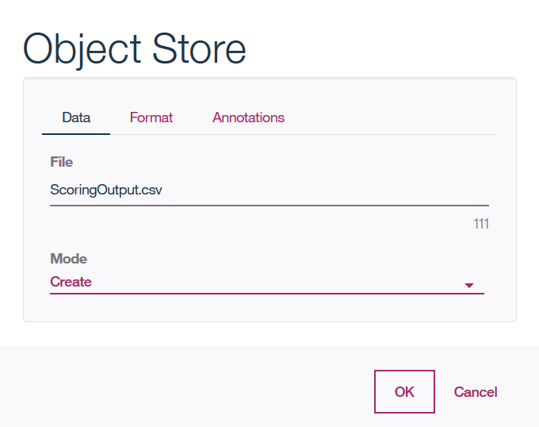

- You can run the entire stream by clicking the Run icon (arrow). When the stream runs, it scores the data and writes it to the specified file in the Object Store as well as the visual output (Table).

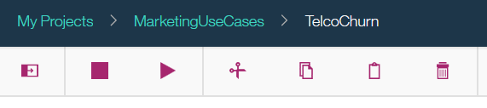

- Table output can be viewed by clicking on the Table in the Outputs view.

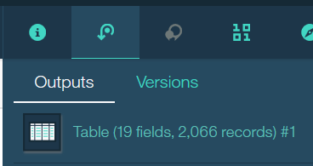

- Scroll all the way to the right and you’ll see two values generated by the model – the predicted value ($C-CHURN) and the confidence in the prediction ($CC-CHURN)

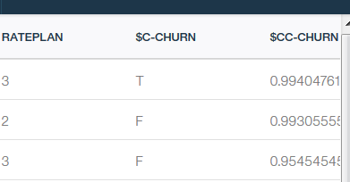

- So far we’ve built and scored the model using the training data. Models are typically evaluated with a different data set. If you wish, you can import the customer_churn.csv data set that’s located in the data folder of the unzipped file from GitHub.

- After adding customer_churn.csv to the Data Assets on the Project page, connect it directly to the model nugget. You will first need to delete a connection from the Type node.

- You can also add the Analysis node from the Output tab and connect it to the model nugget.

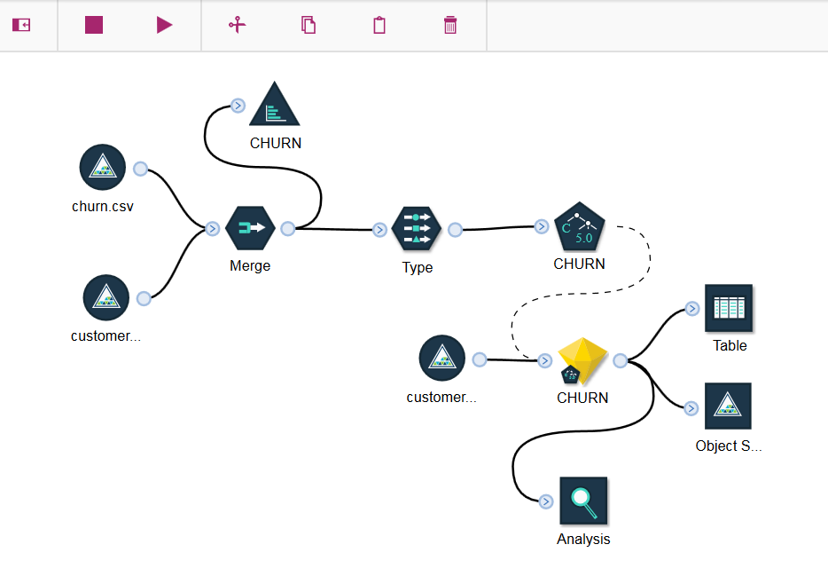

- Right click on the Analysis node and select Run. The results are shown on the Outputs tab.

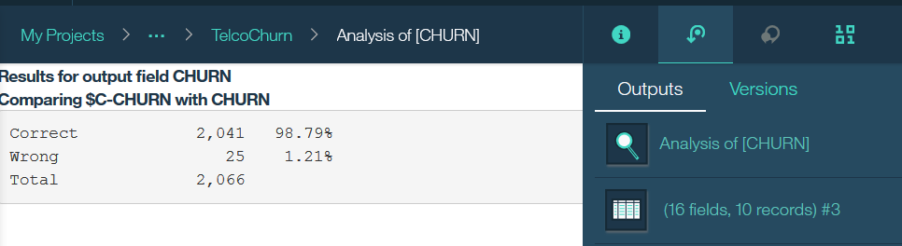

You have finished developing a model to predict customer churn. This model can be deployed in Watson Machine Learning for batch or real time scoring. Once deployed, the model can be integrated with Line of Business applications.

